WEEK OF PRAYER FOR CHRISTIAN UNITY (25-31 May 2020)
EIGHT DAYS of PRAYER
Day 1: Reconciliation: Throwing the cargo overboard
Acts 27: 18-19,21 We were being pounded by the storm so violently that on the next day they began to throw the cargo overboard and on the third day with their own hands they threw the ship’s tackle overboard... Since they had been without food for a long time, Paul then stood up among them and said, ‘You should have listened to me and not have set sail from Crete and thereby avoided this damage and loss’.
Today’s Reading: Mark 16:15-20

Reflection
As Christians from different Churches and Traditions, we have unfortunately, accumulated abundant baggage consisting of mutual distrust, bitterness and suspicion. We thank the Lord for the birth and the growth of the ecumenical movement over the past century. Our encounter with Christians from other traditions and our common prayer for Christian unity encourages us to seek mutual forgiveness, reconciliation and acceptance.
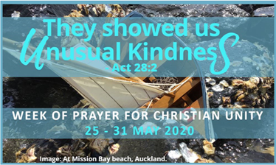
Prayer
E Te Atua,
set us free from painful memories of the past.
Lead us to reconciliation, so that,
through Te Wairua Tapu we may overcome
hatred with love,
anger with gentleness,
and suspicion with trust.
We ask this in the name of your beloved Son, our brother Jesus. Amen.

Day 2: Enlightenment: Seeking and showing forth Christ’s light
Acts 27:20 When neither sun nor stars appeared for many days, and no small tempest raged, all hope of our being saved was at last abandoned.
Today’s reading: Mark 4:35-41

Reflection
Christ is our light and our guide. Without the light and guidance of Christ, we become disorientated. When Christians lose sight of Christ, they grow fearful and divided from one another. Moreover, many people of good will outside the Church are unable to see the light of Christ because in our Christian division we reflect Christ’s light less clearly or, at times, block it out completely. As we seek the light of Christ, we are drawn closer to one another, and so mirror this light more clearly, becoming truly a sign of Christ, the light of the world.
Prayer
God, your word is a light to our steps
and without you we are lost and disorientated.
Enlighten us so that, through your word, we may walk your path.
May our churches crave your guiding, consoling and transforming presence.
Give us the honesty we need to recognize
when we make it difficult for others to see your light,
and the grace we need to share your light with others.
We ask this in the name of your Son, who calls us to be light to the world. Amen

Day 3: Hope: Paul’s message
Acts 27: 22,34 I urge you now to keep up your courage, for there will be no loss of life among you, but only of the ship... none of you will lose a hair from your heads...
Today’s Reading: Matthew 11:28-30

Reflection
As Christians belonging to churches and traditions that are not fully reconciled to one another, we are often discouraged by the lack of progress towards visible unity. Indeed, some have given up all hope and see this unity as an unattainable ideal. Others do not see unity as a necessary part of their Christian faith. As we pray for the gift of visible unity, let us do so with steadfast faith, enduring patience and expectant hope, trusting in God’s loving providence. Unity is the Lord’s prayer for the Church, and he is accompanying us on this journey. We will not be lost.

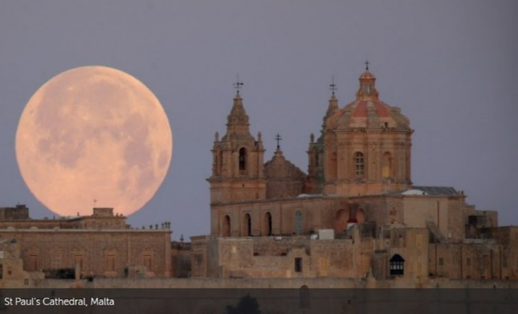
Prayer
God of mercy,
lost and disheartened, we turn to you.
Instill in us your gift of hope.
May our churches hope and strive for the unity
for which your Son prayed on the eve of his passion.
We ask this through him who lives and reigns with you and the Holy Spirit for ever and ever. Amen.

Day 4: Trust: Do not be afraid, believe.
Acts 27:23-26 For the last night there stood by me an angel of the God to whom I belong and whom I worship, and he said, ‘Do not be afraid, Paul; you must stand before the emperor; and indeed, God has granted safety to all those who are sailing with you.’ So, keep up your courage, men, for I have faith in God that it will be exactly as I have been told. But we will have to run aground on some island.
Today’s reading: Luke 12:22-34

Reflection
In the midst of the tempest Paul’s encouragement and hope contradicted the fear and despair of his fellow travelers. Our common call to be disciples of Jesus Christ calls us to stand as witnesses to hope by placing our trust in God’s loving providence. Christian experience shows us that God writes straight on crooked lines, and we know, against all odds, we will not drown or be lost. Because God’s steadfast love endures forever.

Prayer
Atua kaha rawa,
our personal suffering leads us to cry out in pain
and we shrink in fear when we experience sickness, anxiety or the death of loved ones.
Teach us to trust you.
May the churches we belong to be signs of your providential care.
Make us true disciples of your Son
who taught us to listen to your word
and to serve one another.
In confidence we ask this in the name of your Son, and in the power of the Holy Spirit. Amen.

Day 5: Strength: Breaking bread for the journey.
Acts 27:33-36 Just before daybreak, Paul urged all of them to take some food, saying, ‘Today is the fourteenth day that you have been in suspense and remaining without food, having eaten nothing. Therefore, I urge you to take some food, for it will help you survive; for none of you will lose a hair from your heads.’ After he had said this, he took bread; and giving thanks to God in the presence of all, he broke it and began to eat. Then all of them were encouraged and took food for themselves.
Today’s reading: Mark 6:30-44

Reflection
Paul’s invitation to eat is an exhortation to those in the boat to strengthen themselves for what lies ahead. This taking of bread marks a change of attitude, as those in the boat move from despair to courage. In a similar way the Lord’s Supper provides us with food for the journey and re-orientates us to life in God. We are made strong. The breaking of the bread – at the core of Christian community life and worship – builds us up as we commit ourselves to Christian service. We long for the day when all Christians will be able to share at the same table of the Lord’s Supper and draw strength from one bread and one cup.

Prayer

Kia whakapaingia koe, e te Atua
your Son Jesus Christ broke bread
and shared the cup with his friends on the eve of his passion.
May we grow together in closer communion.
Following the example of Paul and the early Christians,
give us strength to build bridges of compassion,
solidarity and harmony.
In the power of the Holy Spirit. Amen.

Day 6: Hospitality: Show unusual kindness.
Acts 28:1-2 After we had reached safety, we then learned that the island was called Malta. The natives showed us unusual kindness. Since it had begun to rain and was cold, they kindled a fire and welcomed all of us round it.
Today’s reading: Luke 14:12-24

Reflection
After the traumas and conflicts of the storm at sea, the practical care offered by the islanders is experienced as an unusual kindness by those washed up on the shores. Such kindness demonstrates our common humanity. When we show kindness to the weak and dispossessed, we are attuning our hearts to the heart of God in which the poor have a special place. Welcoming outsiders, who may be people of other cultures or beliefs, immigrants or refugees, is both to love Christ himself, and to love as God loves. As Christians, we are called to step out in faith and reach out with God’s all-embracing love, even to those we find difficult to love.

Prayer
God of the orphan, the widow and the stranger,
instill in our hearts a deep sense of hospitality.
Open our eyes and hearts.
May our churches participate in the ending of hunger, thirst and isolation
and in overcoming barriers that prevent the welcome of all people.
We ask this in the name of your Son, Jesus, present in the least of our sisters and brothers. Amen.

Day 7: Conversion: Changing our hearts and minds.
Acts 28:3-6 Paul had gathered a bundle of brushwood and was putting it on the fire, when a viper, driven out by the heat, fastened itself on his hand. When the natives saw the creature hanging from his hand, they said to one another, ‘This man must be a murderer; though he has escaped from the sea, justice has not allowed him to live.’ He, however, shook off the creature into the fire and suffered no harm. They were expecting him to swell up or drop dead, but after they had waited a long time and saw that nothing unusual had happened to him, they changed their minds and began to say that he was a god.
Today’s reading: Matthew 18:1-6
Reflection
The locals realized that their judgment of Paul was wrong, so they changed their minds. The extraordinary event with the viper enables the islanders to see things in a new way, a way which might prepare them to hear the message of Christ through Paul. In our search for Christian unity and reconciliation we are often challenged to rethink how we perceive other traditions and cultures. This demands an ongoing conversion to Christ in which the churches learn to overcome their perception of the other as a threat. As a result, we will be drawn closer to unity.


Prayer
Almighty God,
we turn to you with repentant hearts.
In our sincere quest for your truth,
lead the churches to grow in communion.
Help us let go of our fears,
and so better understand each other and the stranger in our midst.
We ask this in the name of the Just One,
your beloved Son, Jesus Christ. Amen.

Day 8: Generosity: Receiving and giving.
Acts 28:8-10 The father of Publius lay sick in bed with fever and dysentery. Paul visited him and cured him by praying and putting his hands on him. After this happened, the rest of the people on the island who had diseases also came and were cured. They bestowed many honors on us, and when we were about to sail, they put on board all the provisions we needed.
Today’s reading: Matthew 10:7-8

Reflection
This story is full of giving and receiving. Paul received unusual kindness from the islanders; Paul gives healing; having lost everything in the storm, the 276 receive abundant provisions as they set sail. As Christians we are called to unusual kindness. But in order to give we must first learn to receive – from Christ and from others. More often than we realize, we are recipients of acts of kindness from people who are different from us. These acts point towards the generosity and healing of God. We who have been healed by the Lord are responsible for passing on that which we have received.

Prayer
God, giver of life,
we thank you for the gift of your compassionate love which soothes and strengthens us.
We pray that our churches may be always open to receive your gifts from one another.
Grant us a spirit of generosity to all as we journey together in the path of Christian unity.
We ask this in the name of your Son who reigns with you and the Holy Spirit. Amen.
For use in Christian communities especially during the Week of Prayer for Christian Unity 25 May – 31 May 2020

